Wellness Center/ Field House for Elizabethtown College
Tommy James, Jake Evans, and Buck Kauffman
Elizabethtown College, Elizabethtown, PA

Abstract

This project is to design a wellness center for the Elizabethtown college campus. This wellness center must embody mind, body, and spirit for all members of campus. It needs to promote a unity of students, faculty, and staff and unity of athletics, academics, and student services. The building must be based off green architecture building techniques, while promoting sustainability. The spiritual aspect must be nondenominational, promoting wellness across cultures and beliefs while excepting all people. This building will consider allowing the outside community to promote communal unity, but is not required.

- Introduction

Elizabethtown College has been investigating and in the preliminary stages of creating a wellness center for the students and faculty. The existing facilities have had their potential maximized. Thompson gymnasium has been renovated multiple times, and does not have a sufficient amount of storage or any more room to expand. The main hub of campus is the BSC and the facilities do not have a “nudge” factor that invites students in. The “Body Shop” weight room is hidden in the basement and the wellness facilities are hidden upstairs of the BSC. The wellness facilities being hidden are good for privacy, but not for student access. The college could make use of a new facility to centralize all wellness activities, and create a new center for students to gather.

- Site Selection

When deciding where to construct a wellness center for the college multiple designs and ideas were presented. These designs included building a multi-story facility that would be connected to the jaywalk, a full size single story building on the Brinser field North of Founders dorm, and a full size building behind the soccer game field where the existing softball field is located.

Due to the fact that a 200 meter NCAA regulation track was one of the main assets of the Wellness Center, the multi-story building attached to the jaywalk design idea was immediately taken out of consideration. Due to the shape and size of the available site, the regulation track would not be feasible.

To make a final selection, the usage of each site was put into perspective. It was determined that a lot of the student body uses the Brinser field for a multitude of purposes including intramurals (Ultimate Frisbee), on-campus events (TGIS), and relaxation purposes (sunbathing). Another important consideration was the safety and everyday life of students during construction. If the Wellness center was built on Brinser field the flow of students would be altered significantly due to the heavy machinery, dust, and other dangers of construction. The fields above the quads are much less traversed and currently only used for athletic purposes including soccer practice and the softball games. When these sports are in the off-season, there is very little movement or usage of these facilities. If the building was built here student movement throughout the day would not be changed, but the practice soccer field and softball field would have to be moved to another location on campus and require additional construction.

After considering the pros and cons of the final two sites we determined the site near the soccer game field would be the best location for the Wellness Center. This location would encourage more students to stray from the centralized “hub” of the BSC and create a more widespread campus. This location would also be simpler for construction because of the ease of access for materials and equipment, and the distance from normal student movement. One disadvantage of this site is the softball field will have to be relocated between the soccer game field and Wolf field. This may require extra construction, but the softball team could see an increase in participation and support from the student body because of its proximity to the rest of campus.

- Design of Wellness Center Facilities

The wellness center will include a large field room in the center, with two wings. One wing with be mainly used for fitness activities, while the other wing will be used for mental and spiritual health.

The main field room will be a large open space with 30 ft. walls and high ceilings. The main feature of this room will be a NCAA regulation 200 meter indoor track including six lanes. This track will give our 90 indoor track athletes a space to practice, and allow our school to host indoor meets. This could provide extra revenue, while also enhancing our student-athletes experience.

Inside the track will be three NCAA regulation basketball courts. These courts will be made out of a durable multipurpose court material called Versacourt. This material comes in rigid interlocking tiles that will be been customized to the schools needs for logos and lines. Versacourt was picked over a traditional wood panel court and another material called Flexcourt. The reason for this was the ease of installation only requiring a flat cement surface. The wood court requires a support structure underneath and Flexcourt requires an extra rubber pad to lie under the tiles. Versacourt also provided a low impact feature that saves athletes backs, knees, and ankles from harsh impact unlike a hardened wood surface. Versacourt comes with a 10 year warranty if any manufacturing problems occur along with an expected lifetime of 30 years. It does not require extra polishing or resurfacing that the wood court requires and initially costs less than the wood courts. These three courts are able to be adapted for multiple athletic practices (indoor and outdoor sports) and multiple intramurals. This will help sports like baseball and softball who will benefit from a batting cage that can be lowered next to the courts. The tennis team will have the ability to put up the nets on all courts. With this new facility varsity teams will be able to hold higher quality indoor practices. All intramurals will benefit from the courts because it will not have to compete with as many varsity sports allowing for a more flexible schedule. To ensure the safety of the people using the track, a netting barrier will be implemented around the outside of the courts. It will be easily to put up or down to suit different needs.

Lining the field room will be six locker rooms, with three on each side. Each of these rooms will have 72 individual lockers lining the walls, with 8 person group showers in each locker room, and 8 bathroom stalls. These locker rooms will be a necessary addition for varsity athletics and will allow every sport to have a space for their athletes. There will be sufficient space for the student body to use the locker rooms, providing students a place to change, shower, etc. In each of the locker rooms the floor will be made from durable ceramic tile, which will give a slip-resistant floor as well as a surface that is easy to clean and take care of.

On the West wing will be the main fitness facilities. There will be a large weight room with free weights and cable machines. Attached will be a separate cardio room with treadmills, bikes, etc. This will be used by the athletes and greater student body, and should accommodate the students better than the existing facilities at the Body Shop and Thompson weight room. One positive feature of this section is it will have windows that face the soccer game field and the rest of campus for a picturesque view.

A training room will be located on this wing, providing rehab care and treatment for athletes and students. This room will include 7 examination tables, 4 whirlpools, 2 bikes, rehab floor space, and sufficient storage space. The existing training room in Thompson Gym will remain in service providing continued care to all athletes at each location. This will give a better experience and a higher quality of care and response time.

Also on this wing there will be seven offices, six for athletic coaches and one for OSA. This provides enough room for coaches whose teams will be using the Wellness center on a regular basis. The OSA office will serve as the intramural and group fitness class headquarters.

In addition to the rooms that are used for daily functions, there is a large equipment room. This room will have sufficient enough storage to house large items for the track and other varsity sports. There will be track equipment (hurdles, mats, etc.), outdoor sports equipment (soccer nets, volleyball nets, tennis nets, etc.) and uniform and clothing storage. Two sets of washers and dryers will be placed in the equipment room to ensure sanitation and cleanliness of the clothing and towels.

With all of the activities available in the west wing it will create a closer knit community for the campus and integrate stronger student to faculty interaction that is currently missing in the weight room and offices. Instead of having the current wellness facilities in different buildings and floors, it will be centrally located to this building and separated by wing.

The wellness center is located on the East side. For large group fitness classes there will be a room available to suit the needs of many interested students. This room will have semi-soundproof walls to minimize disturbances for the rest of the center. To host special events this room will also have 170 chairs available for temporary use. In the back corner of the wing will be the counseling center. This will provide privacy for the patients, and create a safe comfortable environment for those involved. There will be 8 offices/consultation rooms, along with one large conference room for group therapy sessions or small meetings. There will be two sacred spaces for religious reflection and prayer. This space provides a quiet concealed space for all cultures and denominations to take care of their sacred needs. Students can take their time for spiritual healing and well-being, while also providing a space for meditation if necessary.

When you enter the front entrance there will be a concession stand with food and healthy options available for sale. This will provide a social setting for students, along with another dining option. The tables and chairs will be placed in the lobby with large glass windows to look over the soccer game field and the field room. This will create a very inviting entrance and provide another way to watch events in the field room, hopefully increasing the participation of students for soccer games to support their Blue Jays.

Finally, there will be “Jaywalk” type space along the south wall of the building. This will serve as a place for students to work, relax, socialize, and watch over events happening in the field room.

- LEED Certification

When constructing buildings in this day and age, it only makes sense to use the available technology to conserve energy and enhance sustainability. To ensure we made use of these green building techniques and ideas, we used the LEED certification scorecard. This gave guidelines for following the LEED standard and gave us a rough estimate of the certification our design would qualify for.
Location and Transportation
On the exterior of our design we were able to meet some LEED standards and gain points toward certification. First when deciding on a site, we chose a location that would protect sensitive land, while protecting and restoring natural habitats. The site is currently developed and being used as the softball field, so no harm would be done to any undeveloped land. The new softball field would also be placed in a developed area, between the soccer game field and turf, to ensure the safety of sensitive land and natural habitats. We also considered the access to quality transit. The wellness center on this site would be within 2.5 miles of the Amtrak train station. This would provide faculty and possibly the outside community with a close source of mass transit.

When considering how students would get to the facility that currently seems so far out of the norm, we had to think of ways to encourage environmentally safe transportation. We included bicycle facilities directly outside the front door, to encourage students and faculty to use transportation that does not output carbon to the atmosphere. These racks will provide a safe place to keep bicycles locked and peace of mind for the owners while in the facility. Realizing that people will be tempted to drive, we created options to promote green habits. There will be designated spaces in close proximity to the entrance for people with low-emitting and alternative fuel vehicles. This provides an incentive to purchase the “green” vehicles and a reward for those who have already purchased them. Finally, we created a reduced parking footprint by creating the parking lot that only covers 20% of the site. This parking lot will also have preferred spaces available for those who carpool. Carpooling will reduce the carbon output into the environment, and inadvertently create better student and faculty relationships.

Sustainable Sites
Next we considered the rainwater usage and outdoor water use. To collect rainwater all gutters from the rooftops flow into two 500 gallon tanks. The water in these tanks is filtered for large sediment and wildlife reduction, but not for drinking standards. The water is then used in the building as toilet water. In our parking lot we used a new technology to manage rainwater. This material is called “Pervious concrete pavement.” It is made from a mass of aggregate particles covered with a thin paste to create a void within the mixture, allowing for a highly permeable material. This allows water to flow through, slowing down runoff by temporarily storing the rain water in the voids and stone basin. This reduces the need for storm water ponds and sewer systems. The material also naturally filters the water, reducing pollutants that could enter local natural streams and ponds (Lake Placida). Another advantage of this parking lot is the pavement will absorb snow and reduce puddling, thus eliminating a majority of black ice and the need to plow. It also reduces the expense of rock salt since rock salt will clog the porous material. This also reduces the heat island effect around the building due to its lighter complexion compared to asphalt, thus making it easier to grow grass and trees around the lot.
The roof of our building will consist of two types of materials; metal roofing and a green roof. The metal roof will cover the entire structure and will be made entirely from recyclable and local materials. The metal used is lightweight, but very durable providing a good starting support for the green roof that will be implemented on the front of the wellness center. This roof material also provides an easy setup for solar panels placed on the south side of the wellness center. Even though the metal roofing has a greater an initial cost than shingles, there are many government incentives that will help offset the costs. Some of these incentives include percent reduction off fire resistance insurance premium and a reduction of annual energy costs.

The green roof will be placed on the front tier of the roof, covering approximately 50% of the floor plan. This will provide the plants a constant supply of sun due to the north orientation. The green roof itself consists of several layers adding 10 to 35 pounds per square foot. The base layer is a waterproofing membrane to protect the metal roof underneath. The next level is a drainage layer, which is a dimpled mat that allows the filtrated runoff water to run to the rain gutters and then to a water management system. This will reduce the need for potted water and slow down the flow of run off helping the drainage around the building. After that a thin substrate layer is added, where the growing media is implemented. A thin layer of growing media is needed because only plants with shallow root systems are going to be used. On our project we plan on using only sedum, which is a drought resistant plant that grows horizontally and can be installed in rolled out patches providing an easy installation. This type of green roof is called an extensive roof due to the shallow roof system. We could have used and intensive green roof, but this would involve having a deeper growing media for shrubs and trees that would not be beneficial because of the extra weight. There are two main advantages of this green roof. This includes storm water management in the drainage layer and the thermal mass effect that is created for the building. Due to the thickness of the green roof it has the ability slow down the transfer of heat from the roof to the environment. This is good for the summer because it will resist the high heats from infiltrating the wellness center. In the winter the roof will contain the heat requiring less energy used to heat the wellness center constantly. The green roof also has the ability to extend the life span of the base metal roof by three times the expected lifespan because of the lack of exposure.

The other half of the roof will have 120 solar panels mounted. These solar panels will be facing south on the roof at an angle of 30 degrees. This falls in the optimal range of ±15 degrees latitude (approximately 45 degrees for Elizabethtown Pa). These solar panels should be able to produce up to approximately 24 kW of energy, offsetting the grid-tied energy consumption and creating a renewable energy production source.

Inside the actual structure there are numerous features that will account for LEED credits towards certification. Included are multiple sustainable and eco-friendly materials, along with technologies to enhance the energy efficiency.

To manage and control the water consumed by the building, we reduced the indoor usage and utilized water metering. To reduce indoor water usage, rain water will be used in toilets. Toilets do not need clean drinking water to run, since no water is consumed during use. The urinals will be waterless, completely eliminating the water required to flush. To monitor the water consumption of the building, water meters will be attached to indoor plumbing, hot water, and the rainwater collection system. This will give an indication of where the majority of the water is being used.

Energy and Atmosphere
To conserve energy we used advanced energy metering, enhanced refrigerant management, and optimized energy performance. On the heating system there will be energy meters to find how efficient the system is running, and where the majority of the energy is produced. For the air conditioning, we will only use USGBC approved refrigerants. These will be naturally occurring refrigerants with ozone depletion potential at zero, or a global warming potential less than 50. The carbon output will be far less using environmentally safe refrigerants. Finally, optimizing the energy performance will gain LEED credits under the energy and atmosphere category. Energystar light bulbs and appliances will be installed to reduce daily energy consumption. There will also be motion sensors and automatic dimmers in each room to conserve energy. The dimmers will be able to sense the amount of natural daylight and dim or completely shut off the lights to create a comfortable environment. If there is enough natural light energy will not be wasted on lighting a lit room. This will create a better source of ambient light, with only one source instead of natural and artificial light that often is unpleasant for the eyes. The motion sensors will be used as a last resort, as we do not want people to get into the lazy habit of relying on sensors to shut off the lights when leaving a room. This is not a good habit to form, since many other buildings have not yet implemented sensors.

Indoor Environmental Quality
On the interior LEED places an emphasis on the indoor environmental quality. In our design we met the needs of multiple categories. To make sure the air quality is exceptable for the building many steps were taken. Before the building begins construction, we will have an indoor air quality assessment. The tests will check the levels of formaldehyde and volatile organic compounds. To ensure the building passes that test, we will use low emitting materials. These include water-based paints, coatings, and sealers that meet VOC limits. These materials will ensure the safety of the patrons of the wellness center. To decrease the particulates in the air during operation we installed floor mats at the entrances to capture foreign dirt and dust. These mats will be cleaned regularly to avoid build up that could lower the efficiency. Hepa-filters will be placed on the vents to filter the outdoor air for superior air quality. CO₂ monitors will be placed throughout the building to make sure the levels do not enter a dangerous quantity.

Another important aspect for the wellness center is the comfort of the users. This applies to heating and cooling, lighting, and the way sound travels. For the thermal comfort of the students and faculty using the building, we will have a HVAC system that meets ASHRAE standard 55-2004, and conduct a survey 6-18 months after opening. After conducting this survey, we will have a plan in place if over 20% of the occupants are dissatisfied and uncomfortable. For the comfort of people using the wellness center, light is an important factor. The amount of daylight and artificial light must be monitored for optimal comfort. For internal lighting we used three requirements to obtain LEED credits. The first requires all light fixtures to have a luminance less than 2,500 cd/m². This creates a comfortable amount of light indoors that is an easy transition from the outdoors for the eyes. Next the light sources must have a color rendering index (CRI) of 80 or higher. The CRI is the measure of color in comparison to natural light. The sun has a color rendering index of 100, which is the maximum possible. The higher the CRI, the more comfortable it is for humans since we are used to natural sunlight. We will also install light sources that have an expected life span of 24,000 hours. This will save maintenance expenses in the future. Our building will have a large amount of daylight from large windows on the north side and multiple windows along all the walls. The field house will have daylight through the large glass windows along with overhead clerestories. Finally, the acoustic performance of a building is key for user comfort and happiness. To decrease background noise from machinery and HVAC it is important to take measures towards soundproofing classrooms and the HVAC itself. This will be done with commonly used insulating materials proven to reduce noise. In the field room there will be some sound fixtures dampening on the walls and ceiling to reduce echoing.

Materials and Resources
Once the design is in place, there are many considerations that need to be accounted for in construction management. It is essential for the construction to be mindful of the surrounding habitats and avoid pollution at all costs. Using local or recycled materials is important for reducing the carbon footprint and supporting the community. We will use 50% recycled materials, including bricks, tiles, and metal roofing. These recycled materials will be taken from old structures, which could be a unique characteristic of the building and include historical aspects from the community. The raw materials we do use will be purchased from a local supplier, lowering the cost of shipping for us, and reducing the carbon footprint of the transportation. To be mindful of the surroundings at the college we need to have a construction and demolition waste management plan. The plan includes erosion and sediment control to make sure the construction waste does not affect the local ecosystem. There will be temporary barriers assembled around the site to contain the construction waste. We will also have designated waste containers for any materials that can be recycled, and aim for 75% of the waste to be in the container.

- Conclusion

After taking the requests of Dean Calenda, the school board, and green architecture building techniques our design met the needs of the school, while also being LEED certified. After totaling our LEED scorecard we determined we scored 52 points, granting Silver certification. This building will serve the mind, body, and spirit needs of students and faculty while being energy conscious and ecofriendly. During the semester the facility will be closed to the community to allow students to take full advantage of the wellness center. Over summer and winter breaks the facility will be available for lease for events and other activities. This wellness center will be a great addition to the Elizabethtown College campus giving everyone on campus a space to refresh multiple aspects of their life and promote healthier lifestyles.

Resources
"Benefits of Cool Metal Roofing." Cool Metal Roofing. Cool Metal Roofing, 2006. Web. 09 Dec. 2014.
"Download PDFs." Green Roofs as a Tool for Solving the Rainwater Runoff Problem in the Urbanized 21st Century? N.p., n.d. Web. 09 Dec. 2014.
"Extensive Green Roofs: A Primer." Green Roof Plan. N.p., 8 Oct. 2010. Web. 09 Dec. 2014.
"LID Urban Design Tools - Green Roofs." LID Urban Design Tools - Green Roofs. N.p., n.d. Web. 09 Dec. 2014.
"LiveRoof Hybrid Green Roofs | Green Roof LEED Credits." LiveRoof Hybrid Green Roofs RSS2. N.p., n.d. Web. 09 Dec. 2014.
Maynard, Nigel F. "Longevity, Durability, and Recyclability: Metal Roofing a Good Choice for Sustainable Building." Remodeling. Hanleywood, 25 June 2008. Web. 09 Dec. 2014.
Ashley, Erin. "Benefits." :: Pervious Pavement. Concrete InFocus, Winter 2008. Web. 09 Dec. 2014.
Caksmith. "Permeable Paving Syste." PERMEABLE PAVING SYSTEMS (n.d.): n. pag. Vbgov.com. Web. 9 Dec. 2014.
"Pervious Concrete Pavement." United States Environmental Protection Agency. EPA, 2 July 2014. Web. 09 Dec. 2014.
Tennis, Paul D., Michael L. Leming, and David J. Akers. Pervious Concrete Pavements. Skokie, IL: Portland Cement Association, 2004. Myscmap.sc.gov. NRCA, 2004. Web. 9 Dec. 2014.
"Construction." Monthly Labor Review 64.6 (1947): 1108-116. Track Dimensions. NCAA, 2014. Web. 9 Dec. 2014.
"Flex Court Athletics - Athletic Sports Flooring." Flex Court Athletics - Athletic Sports Flooring. N.p., 2014. Web. 09 Dec. 2014.
"Hardwood Gym Flooring For Basketball, Volleyball & More." Basketball Floor. Signature Systems Group, 2014. Web. 09 Dec. 2014.
"Mens College (NCAA) Basketball Court Dimension Diagram." Mens College NCAA Basketball Court Dimensions Diagram. NCAA, 2014. Web. 09 Dec. 2014.
"Why VersaCourt." VersaCourt. Recreational Solutions Group, 2014. Web. 09 Dec. 2014.

Appendices
- Pugh Tables
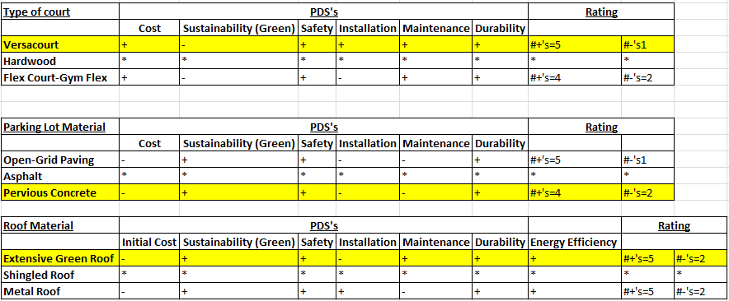
- Green Roof
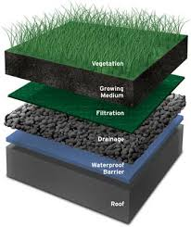

- Pervious Pavement
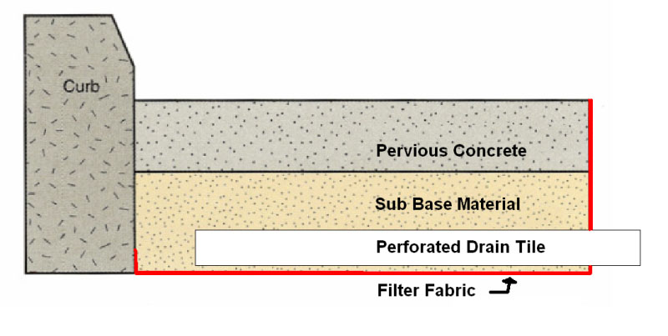
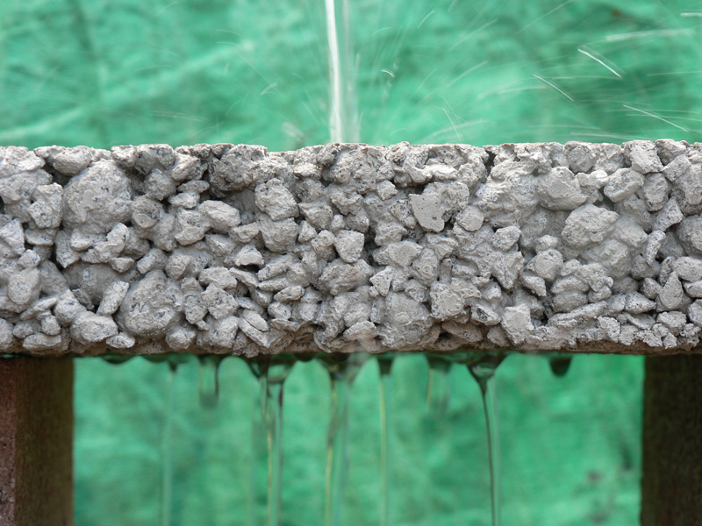

- Site Selection
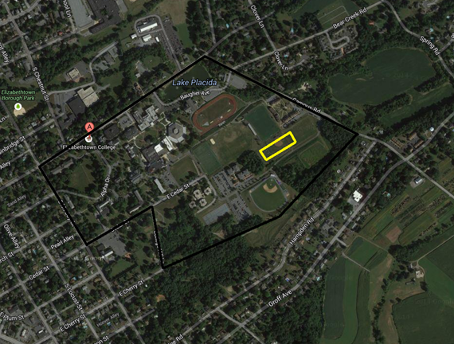
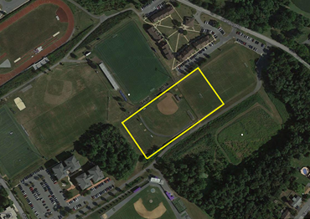

- LEED Scorecard

